Sample Document – Italy

Geography

What is the capital of Italy?
The capital of Italy is Rome. It is located toward the middle of Italy.
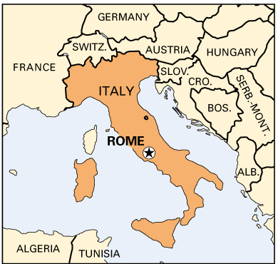
Photo Source: https://www.thinglink.com/scene/691962905213534209

What countries border Italy?
The countries that border Italy include Austria, France, Slovenia, and Switzerland.

Largest lakes
The five largest lakes in Italy include Garda, Maggiore, Como, Trasimeno, and Bolsena.
For more information on other lakes around Italy, follow this please click here.

Longest river
The longest river in Italy is called The Po. Flowing approximately 405 miles long, it runs from the Northwestern side of the Alps, ending in the Adriatic Sea.

What are the different regions of Italy?
There are 20 regions throughout Italy. Here is a map showing the name of each region, as well as where it is located within Italy.
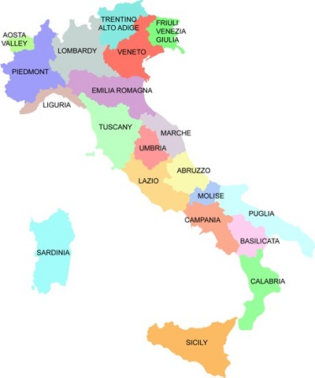
Photo Source: https://www.pinterest.com/pin/418764465321477995/

Climate
The climate around Italy varies dramatically from the northern to the southern regions.
In Northern Italy the climate is usually very harsh with extremely hot, and humid summers and very cold winters.
Typically, central Italy has a milder climate. The intense cold winters are shorter, and summers are longer. The range in temperature from winter to summer is a less drastic change than in the North.
Southern Italy, including the islands, doesn’t receive harsh winters. The summers are comparable to the rest of the land, very sunny and dry.

Demographics

What is the population of Italy?
At the beginning of 2016 it was recorded that about 60,656,000 people live in Italy. That means approximately 201 people live per square kilometer. However, the population is very uneven throughout the land, with a surplus of people populating major metropolitan cities and less living in the rural areas.

Languages

What is the official language of Italy?
The official language of Italy is Italian.

Dialects
Dialects were more common before the turn of the 20th century. Different regions would have slight variations in the way they would word something. For example, people from Venice might say “we are arriving” as “sémo drio rivàr” which is quite different than the standard Italian “stiamo arrivando.”
Today, multiple dialects are not as common. With the establishment of a national education system, and the popularity of television and mass media in the 1950’s, a noticeable decrease in dialect followed.

Is there an official religion of Italy?
While the majority of people in Italy identify as Roman Catholic (~80%), it is no longer officially the state religion. Although, in the past two decades, the number of minority religions has increased significantly, creating more diversity among communities.

Population of metropolitan cities in Italy
Metropolitan City | Region | Population
Rome | Lazio | 2.627M
Milan | Lombardy | 1.251M
Naples | Campania | 960,079
Turin | Piedmont | 870,702
Palermo | Sicily | 655,908
Florence | Tuscany | 361,679
Venice | Veneto | 260,060
Trieste | Friuli-Venezia Giulia | 201,481
These numbers are based off of findings from 2012.

Economy

How does Italy’s economy compare to others?
Italy is recognized as one of the world’s most industrialized countries. Here are a few facts about how Italy’s economy ranks compared to the rest of the world.
- Italy is ranked as the 3rd largest economy in the Euro Zone, 8th largest by nominal GDP in the world and 12th largest by GDP.
- Italy is the world’s 6th largest manufacturing nation.
- As of 2016, Italy is the world’s 8th largest exporter.
- Italy is considered a highly developed country, ranking as the 8th highest in quality of life.

What type of currency is used in Italy?
Italy has been using the Euro since 2002. Before that it was the Lira.

Unemployment rate
As of April 2015, the unemployment rate is 11.4%. To compare Italy’s unemployment rate to other countries, click here.

Politics

Major political parties of Italy
To name a few…
- Democratic Party
- Forza Italia
- The Five Stars Movement

Where does the President of Italy live?
The President resides in the capital, Rome, at the Quirinale Palace.

How long is the President’s term in office?
A regular term of presidency in Italy lasts 7 years.

Parliament
The parliament consists of two assemblies: the Senate and the Chamber of Deputies. These two chambers have equal power and are elected by the people.
One of the most important functions of parliament is ordinary legislation. Various groups (government, individuals, regional councils, etc.) may present a bill to the parliament, but need to be approved by both houses before it becomes a law.

Elected Officials

Who is the President of Italy?
Since 2015, Sergio Mattarella has been the President of Italy.

Who is the Prime Minister of Italy?
Since 2014, Matteo Renzi has been the Prime Minister of Italy.

Culture

Art

Famous artists

Michelangelo
Michelangelo di Lodovico Buonarroti Simoni was born on March 6, 1475 and passed away in February of 1564. He was an Italian sculptor, painter, architect, and poet of the High Renaissance who had a great impact of the development of Western art.
His work can be found around Rome and the Vatican City. One of his most famous masterpieces he is known for is his work done on the Sistine Chapel in Rome.

Leonardo da Vinci
Leonardo da Vinci was born in 1452 in the hills of Tuscany. He later became the epitome of the term “Renaissance Man.” He was a devote student to the study of sciences, painter, architect, and inventor. What he is most known for is his paintings of the “Mona Lisa” and “the Last Supper.”

Famous musicians

Andrea Bocelli
Andrea Bocelli is a well-known pianist/ recording artist. He was born in 1958 with visual impairment. He had learned how to play various instruments as a child. After a soccer injury when he was 12 years old, Bocelli become permanently blind.
He has gone on be to be a very successful musician, being nominated for multiple Grammys, and collaborating with some of the biggest names in music including Jennifer Lopez, Celine Dion, and Nelly Furtado.

Giuseppe Verdi
Verdi was an opera composer of the 1800’s. His work was influenced by Bellini, Donizetti, and Rossini, but ultimately became one of the most distinguished opera composers in history.
In no particular order, some of his work includes Rigoletto, Il trovatore, and Aida.

Cuisine

What is the most popular food in Italy?
Pasta is a major staple in Italian kitchens, and Italian’s are known for making some of the greatest pasta recipes in the world. A few examples of traditional pasta dishes include:
- Ravioli
- Spaghetti
- Lasagna
- Carbonara
- Gnocchi

Cuisine specific to region
All of Italy’s regions have a distinctive cuisine. This has to do in part because of the climate, and also history. For example, you can find truffles and creamy Gorgonzola in the northern region of Piedmont; cured meat and flavorful tomatoes in the central region of Umbria; and seafood in the Southern region of Sicily.
Since there are specific foods that are more robust in specific regions, these regions also design specific shapes of pasta that will hold the sauce the best. Below is a map of some of the pasta shapes created in different regions.
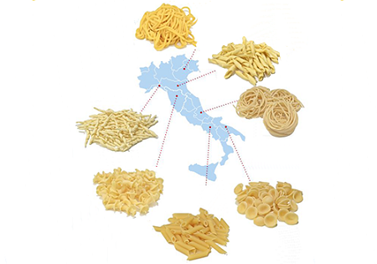
Photo source: http://www.bbcgoodfood.com/howto/guide/guide-pasta-shapes-italy

Sports

What is the most popular sport in Italy?
Soccer, or as it is called in Italy Football, is the most popular sport in Italy.

The Italian national soccer team
I understand you want to know facts about the soccer team. Here are a few that I know.
- The nickname for the Italian national soccer team is Gli Azzuri. Translated in English that means “The Blues.” This stems from blue being the traditional color of Italian national teams.
- The team has won 4 FIFA World Cup titles (1934, 1938, 1982, and 2006). In 1938, they were the first team to defend their previous World Cup title from 1934.
- Currently, the head coach’s name is Giampiero Ventura.

